SIMULATION EXPERIMENT –6

6. Design and Analysis of FIR Digital Filters Using Fourier Series and Windowing Techniques Using MATLAB
Objectives of this Experiment:
1. To design FIR digital filters using the Fourier-series/windowing approach for specified frequency requirements.
2. To implement rectangular, Hamming, Hanning and Blackman window functions and obtain the corresponding FIR coefficients.
3. To analyze the magnitude and phase responses, filter order and transition width for the different windows.
4. To compare the responses obtained using the different windowing techniques and verify the specified frequency characteristics.
PROGRAM:
clear; clc; close all;

Fs = 8000;
fc = 1500;
wc = fc / (Fs/2); % Normalized cutoff frequency
N = 50; % Filter order

% Window Functions
w_rect = rectwin(N+1);
w_hamm = hamming(N+1);
w_hann = hann(N+1);
w_black = blackman(N+1);

% FIR Filter Design using fir1
b_rect = fir1(N, wc, w_rect);
b_hamm = fir1(N, wc, w_hamm);
b_hann = fir1(N, wc, w_hann);
b_black = fir1(N, wc, w_black);

% Frequency Response Calculation
[H_rect, f] = freqz(b_rect, 1, 1024, Fs);
[H_hamm, ~] = freqz(b_hamm, 1, 1024, Fs);
[H_hann, ~] = freqz(b_hann, 1, 1024, Fs);
[H_black, ~] = freqz(b_black, 1, 1024, Fs);

% ==========================================
% DISPLAY NUMERICAL OUTPUTS IN COMMAND WINDOW
% ==========================================
fprintf('=== EXPERIMENT 6: FIR WINDOWING TECHNIQUES ===\n\n');
fprintf('Filter Order (N): %d\n', N);
fprintf('Cutoff Frequency: %d Hz\n\n', fc);

fprintf('--- RECTANGULAR WINDOW COEFFICIENTS (First 5) ---\n');
disp(b_rect(1:5));

fprintf('--- HAMMING WINDOW COEFFICIENTS (First 5) ---\n');
disp(b_hamm(1:5));

fprintf('--- HANNING WINDOW COEFFICIENTS (First 5) ---\n');
disp(b_hann(1:5));

fprintf('--- BLACKMAN WINDOW COEFFICIENTS (First 5) ---\n');
disp(b_black(1:5));

% Plotting
figure('Name', 'FIR Windowing Techniques Comparison');
subplot(2,1,1);
plot(f, 20*log10(abs(H_rect)), 'k', 'LineWidth', 1); hold on;
plot(f, 20*log10(abs(H_hamm)), 'b', 'LineWidth', 1.5);
plot(f, 20*log10(abs(H_hann)), 'g', 'LineWidth', 1.5);
plot(f, 20*log10(abs(H_black)), 'r', 'LineWidth', 1.5); grid on;
legend('Rectangular', 'Hamming', 'Hanning', 'Blackman');
title('FIR Low-Pass Filter Magnitude Response (N = 50)');
xlabel('Frequency (Hz)'); ylabel('Magnitude (dB)'); ylim([-100 10]);

subplot(2,1,2);
plot(f, angle(H_hamm)*180/pi, 'b', 'LineWidth', 1.5); grid on;
title('Linear Phase Response (Hamming Window Example)');
xlabel('Frequency (Hz)'); ylabel('Phase (degrees)');
OUTPUT:
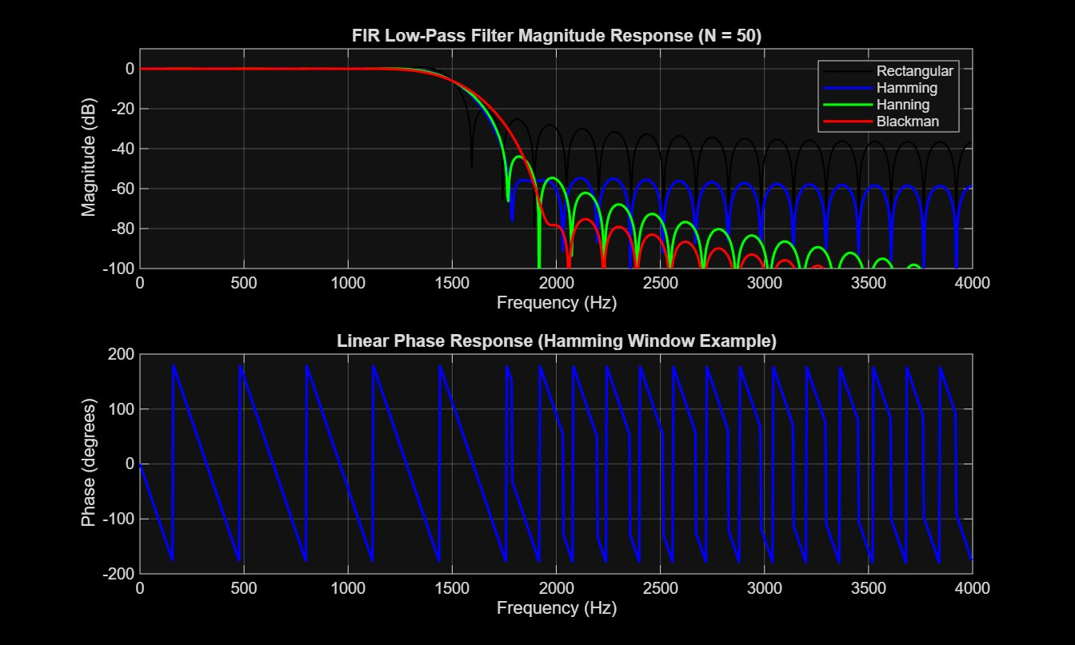
RESULT:
=== EXPERIMENT 6: FIR WINDOWING TECHNIQUES ===

Filter Order (N): 50
Cutoff Frequency: 1500 Hz

--- RECTANGULAR WINDOW COEFFICIENTS (First 5) ---
-0.0118 0 0.0128 0.0103 -0.0058

--- HAMMING WINDOW COEFFICIENTS (First 5) ---
-0.0009 0 0.0012 0.0011 -0.0008

--- HANNING WINDOW COEFFICIENTS (First 5) ---
1.0e-03 *

0 0 0.2009 0.3592 -0.3588

--- BLACKMAN WINDOW COEFFICIENTS (First 5) ---
1.0e-03 *

0 0 0.0743 0.1374 -0.1434

>>

